9. Implement Image Scaling Techniques to Resize Images to Bigger and Smaller Sizes
Aim: To implement image scaling techniques in Python using OpenCV to resize an image to both bigger and smaller sizes.
Procedure
- Import the OpenCV library.
- Read the input image.
- Resize the image to a bigger size using cv2.resize().
- Resize the image to a smaller size using cv2.resize().
- Display the original, enlarged, and reduced images.
Code
import cv2

img = cv2.imread("sample.jpg")

if img is not None:
bigger = cv2.resize(img, None, fx=2, fy=2)
smaller = cv2.resize(img, None, fx=0.5, fy=0.5)

cv2.imshow("Original Image", img)
cv2.imshow("Bigger Image", bigger)
cv2.imshow("Smaller Image", smaller)

cv2.waitKey(0)
cv2.destroyAllWindows()
else:
print("Image not found")
Input
An image named sample.jpg saved in the same folder as the Python program.
Output

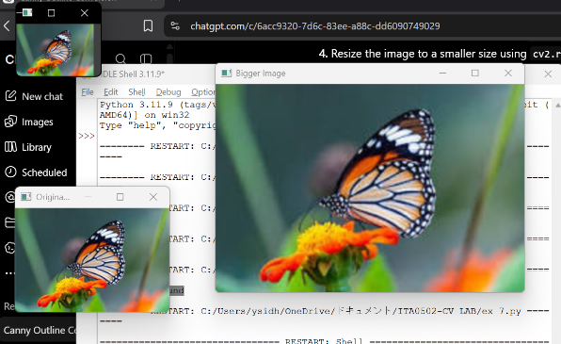
- Original Image: Displays the original image.
- Bigger Image: Displays the image enlarged to twice its original width and height.
- Smaller Image: Displays the image reduced to half its original width and height.
Result
Image scaling was successfully implemented using OpenCV to resize the input image to both bigger and smaller sizes.

